ECE 438 Lab, division 1
Lab 08 (week 12): Number Representation and Waveform Quantization

Shijia Shu, [50%]_ _ _ _ _ _ _
Junyan Shi, [50%]_ _ _ _ _ _ _

April 6, 2016

3.3
1) As the number of bits is lowered, there is more distortions due to the quantization error
2) 2b/pel
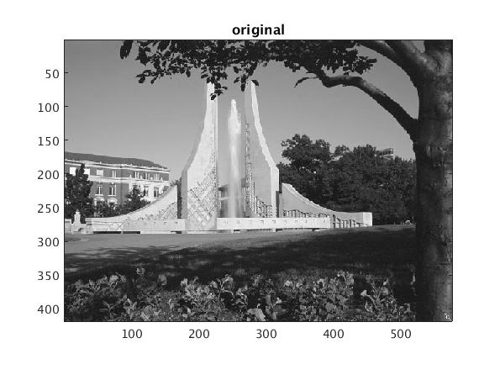
3)

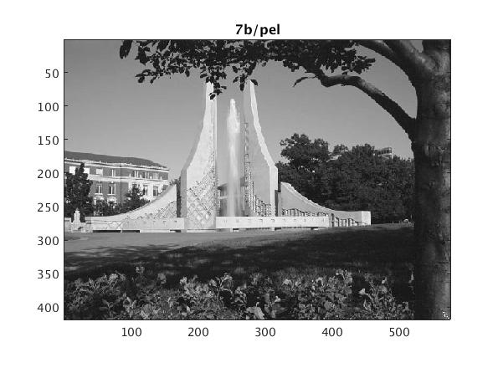
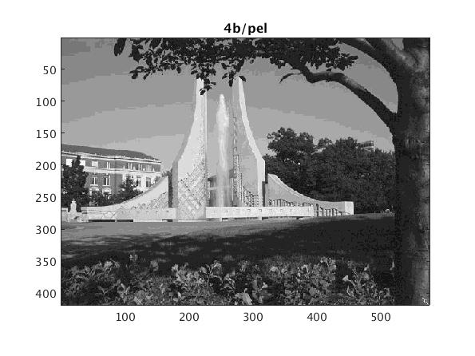
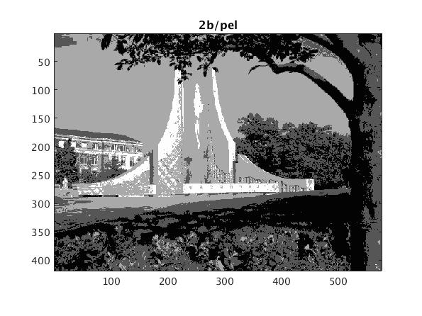

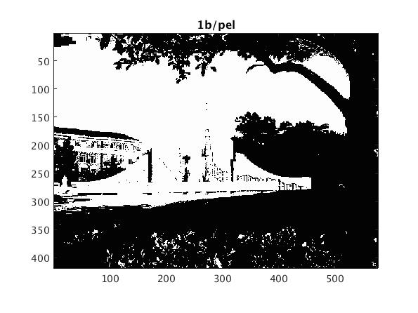
4) image with 7b/pel looks almost same as the original, image with 4b/pel looks almost same except the
quantization error on the sky. Image with 2b/pel is not very good, image with 1b/pel only have black and white pixels.

3.4
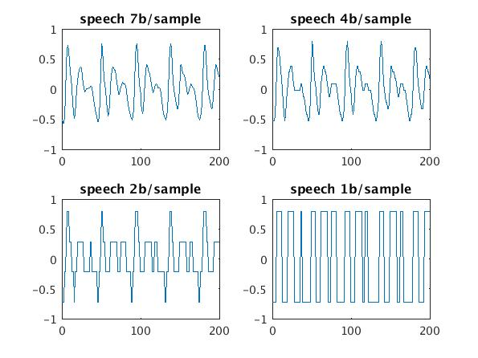
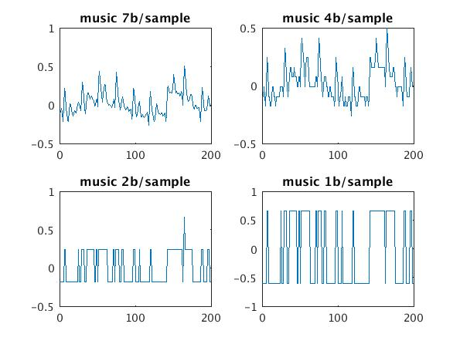
3.4.1
part 1
1)
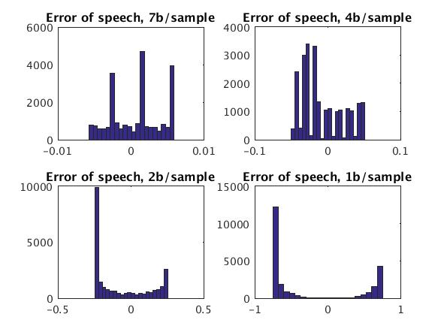
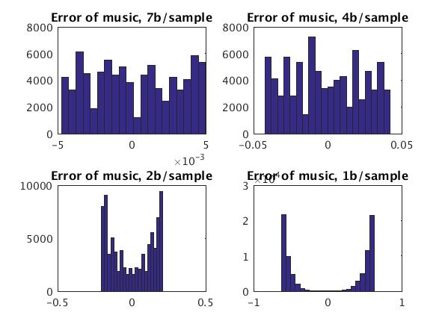

2) The more quantization levels, the narrower the distribution of error is.
3) because the signal is not uniform
part 2
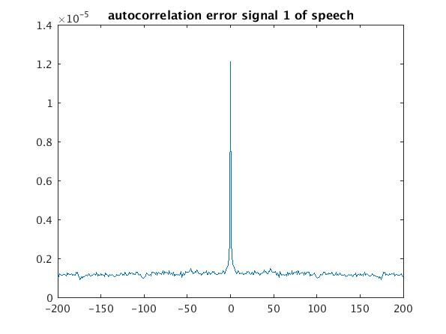
1)
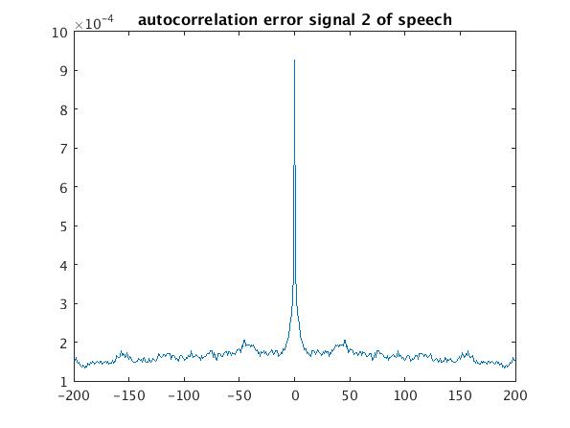

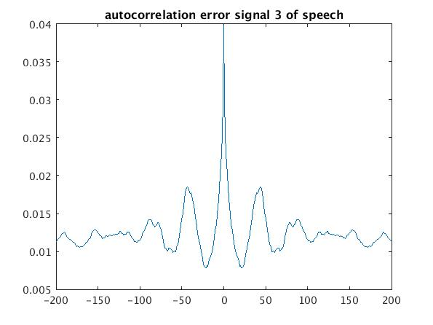
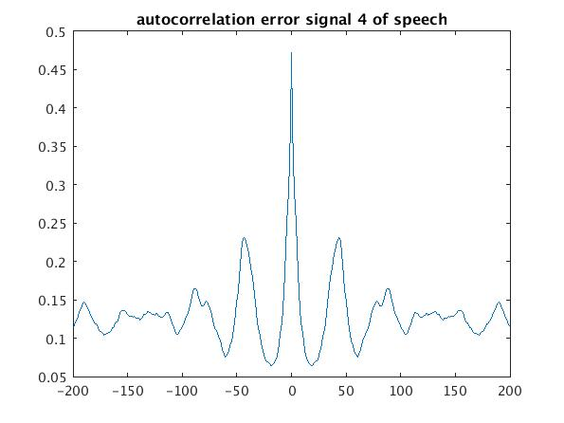

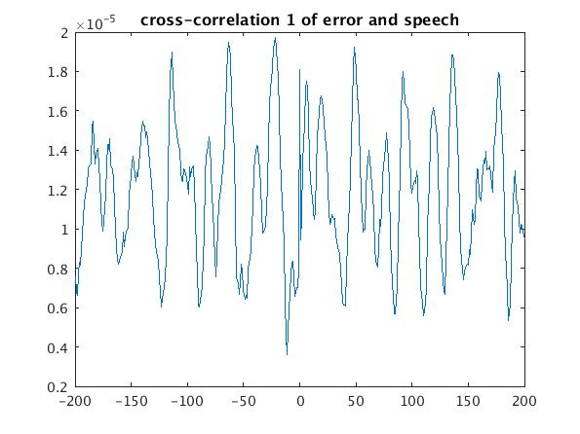
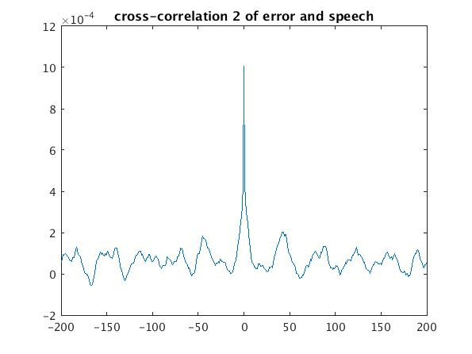

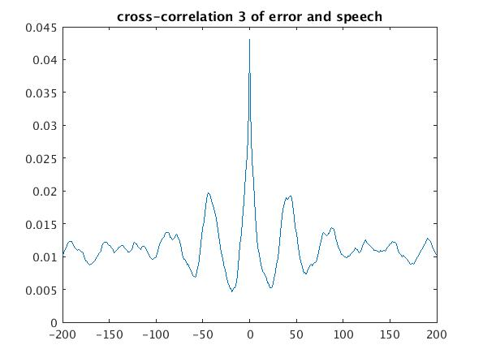
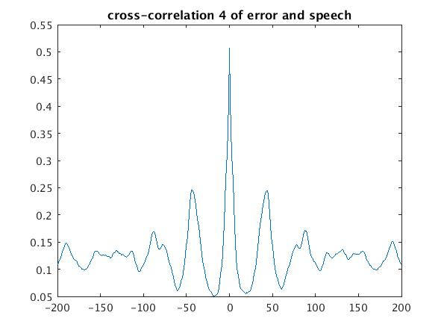

2) the autocorrelation is influenced by the number of quantization levels. The samples in error signal appear not correlated with each other
3) The number of quantization levels influence the cross-correlation

3.4.2
n = [7,4,2,1];
PSNR

PSNR =

1.0e+03 *

1.3255 0.0184 0.0016 0.0012

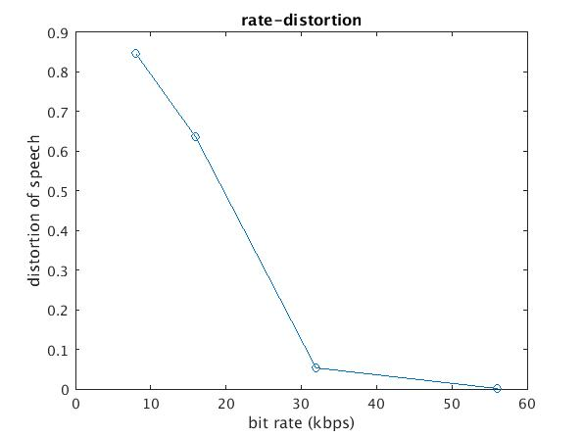

3.5
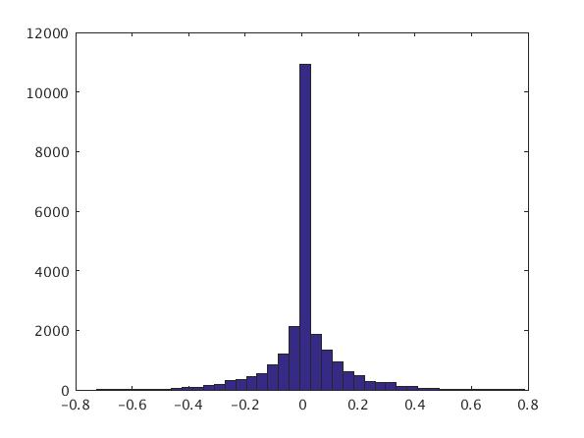
1)

2) PSNR2 =

4.4310
PSNR is greater and Max-quantized signal is better than the uniform-quantized one.
3) if the speech signal is uniformly distributed, the two quantizers will be the same.
Because when it is uniformly distributed, the quantization levels of max quantizer is also uniformed, which is same as the uniform-quantizer's

